**Creation of Payment Lots**

**T Code:** FP05

Step 1: Using the above T Code navigate to the Payment Lot screen and create a new Payment Lot

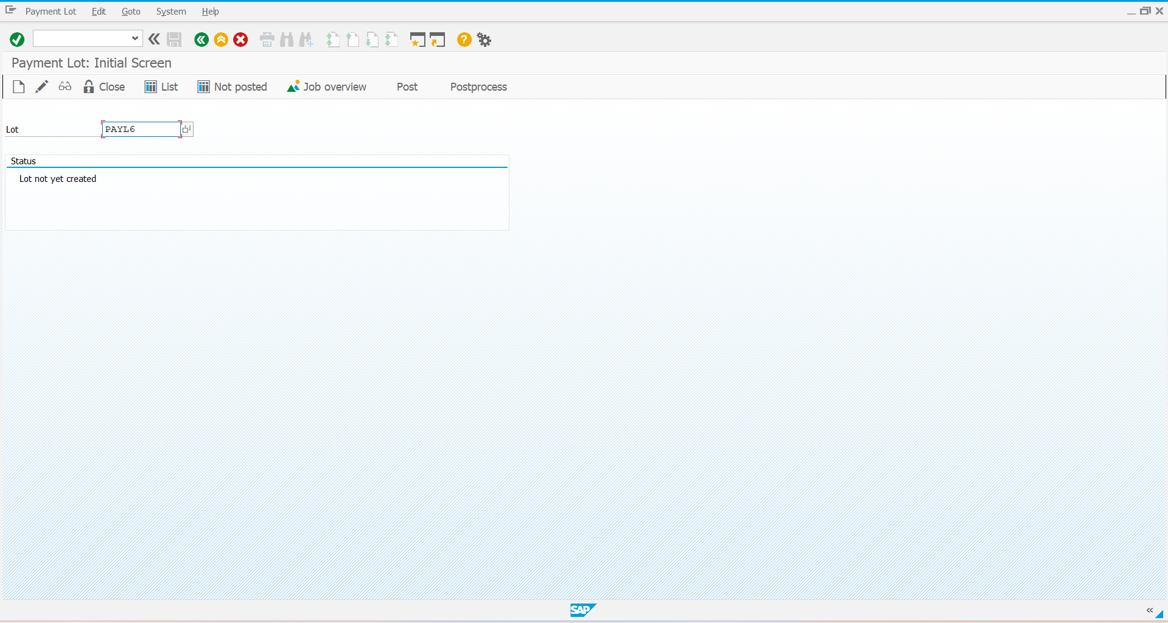

Step 2: Enter the required details, save and select new entries

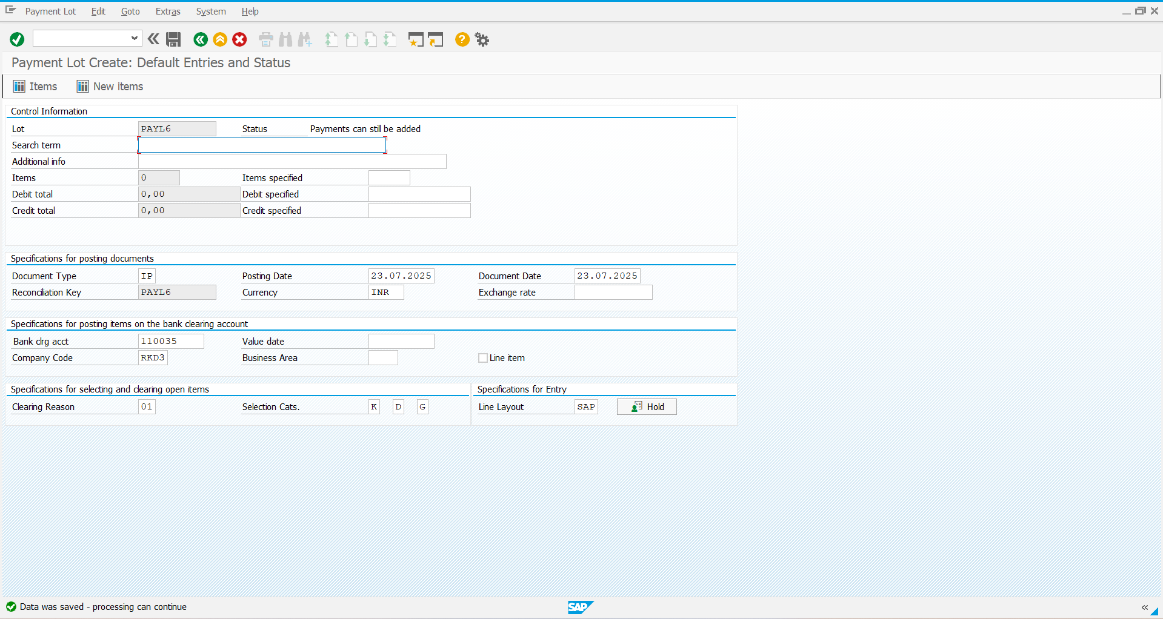

Step 3: Enter the required details to create the Payment Lot and save

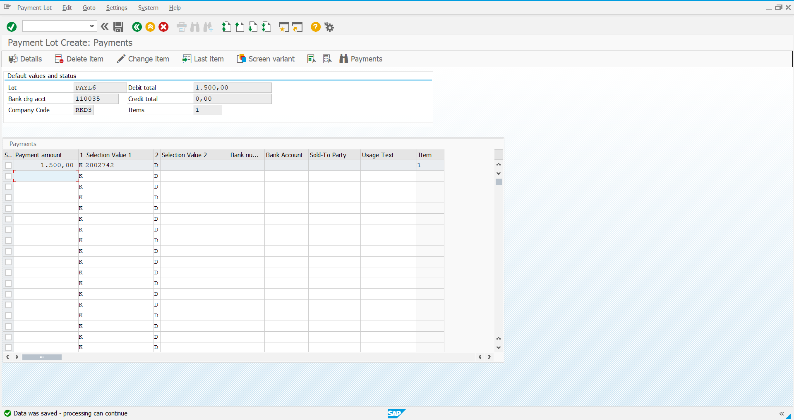

Step 4: Come back to the initial screen, close the lot and post it

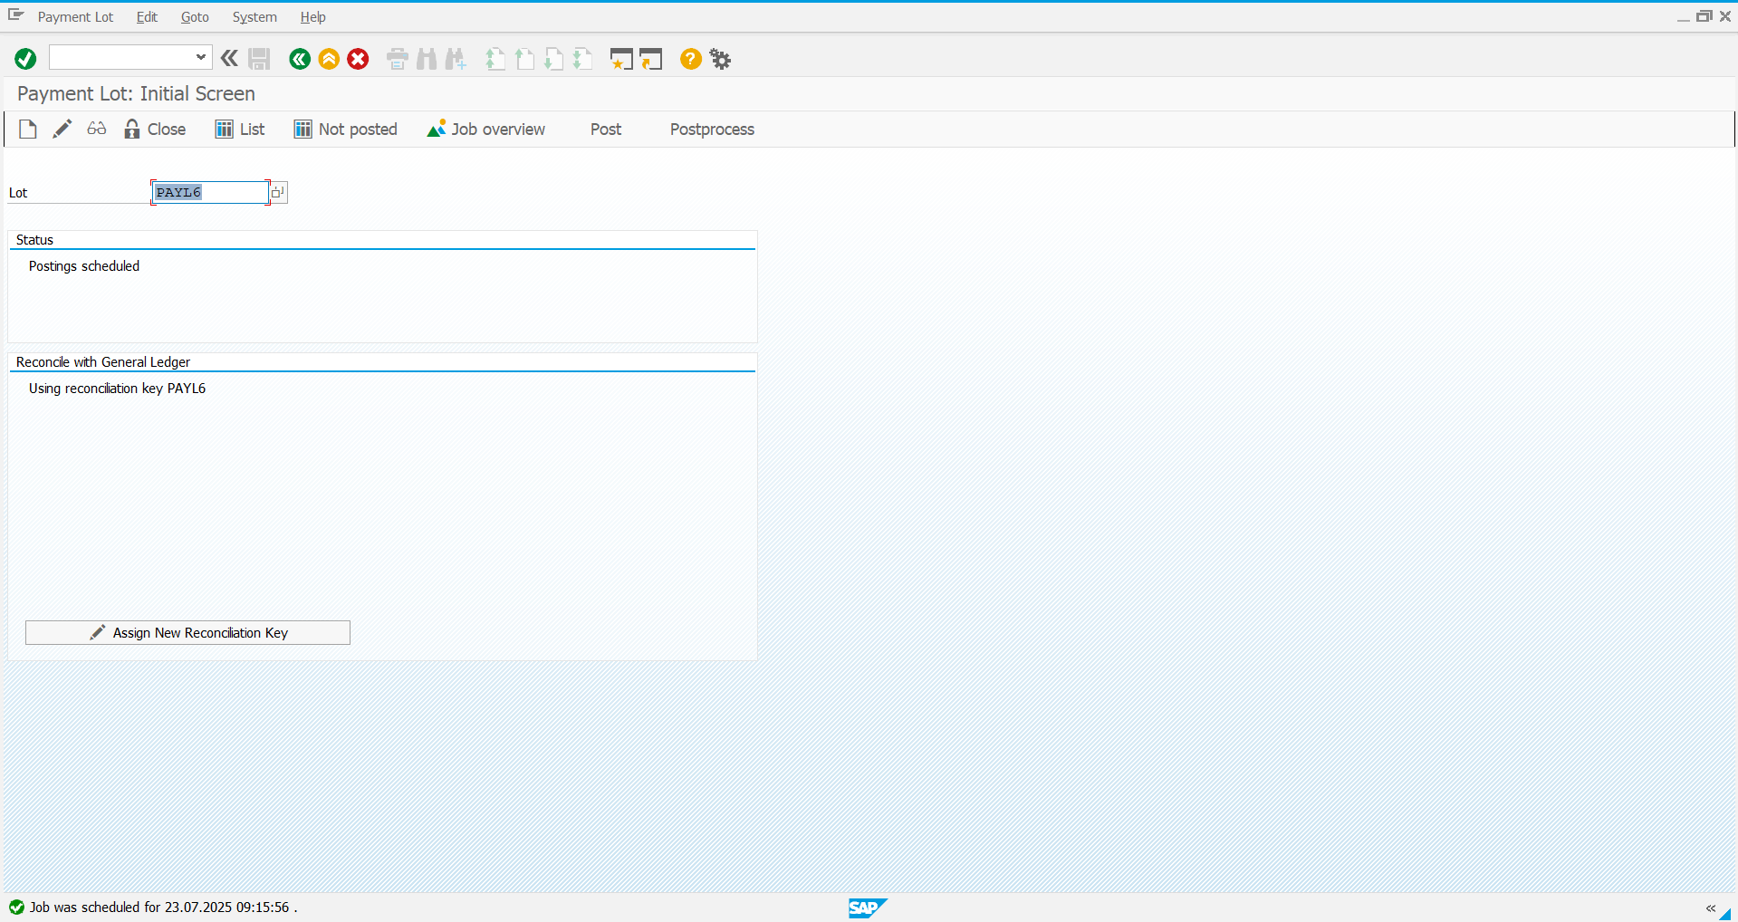

Step 5: Use the **T Code: FPL9** to check if the posting is completed

